Project Development Phase Model Performance Test

Date | 05 February 2026
Team ID | LTVIP2026TMIDS24102
Project Name | Heritage Treasures: An In-Depth Analysis of UNESCO World Heritage Sites in Tableau
Maximum Marks | 5 Marks

Functional Requirements:
Following are the functional requirements of the proposed solution.

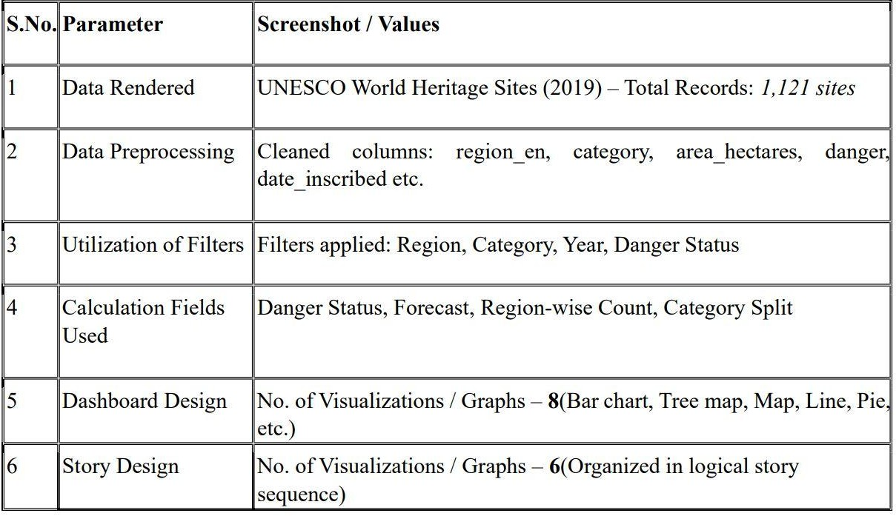

Some visualisations:

